TAYSIDE COMMUNITY JUSTICE AUTHORITY

Meeting: Tayside Community Justice Authority – 14 June 2016

Title: Report on Local Authority Community Payback Order Annual Reports

Report by: Karen Moir, Strategic Planning Officer, Tayside Community Justice Authority

Report No: TCJA266-2016

Abstract – This report presents Members with the local authority CPO Annual Reports for the 2014-15 period, which the local authorities were required to submit to Government by 11 November 2015.

1. Recommendation(s)

It is recommended that the Authority:

1.1 notes the content of the annual reports on CPOs from the CJA’s constituent local authority Criminal Justice Social Work services to the Scottish Government.

2. Background

2.1 Community Payback Orders and the related statutory presumption against prison sentences of 3 months or less, have been available to the courts since the 1st February 2011.

2.2 The delivery of effective community-based disposals such as Community Payback Orders is one of Tayside CJA’s 7 Priorities in the Area Plan for 2014-17.

2.3 This report presents to Members the fourth round of local authority annual reports to the Government on the operation of the Community Payback Orders, covering the financial year 2014-15. They outline: how CPOs have been implemented; sentencing trends; performance; emerging issues; and future priorities. They also illustrate the nature and extent of partnership work with other agencies and the development of related initiatives across the criminal justice system.

3. Local Authority CPO Annual Reports 2014-15

3.1 The local authority CPO annual reports are included as appendices 1 – 3.

3.2 Structure of the Reports

3.3 Local Authorities are required to report to Government on the operation of Community Payback Orders, outlining: how CPOs have been implemented; sentencing trends; performance; emerging issues; and future priorities.

3.4 The Annual Reports exist as completed proforma, provided by and completed for the Scottish Government, each containing the following information:

- a description of the types of unpaid work projects and activities which have been carried out;
- the total number of unpaid work hours completed during the year;
- information that helps to demonstrate how communities benefit from unpaid work
- if available, quotes from offenders and beneficiaries about the impact of the unpaid work on them and the community;
- a description of the kinds of "other activity" carried out as part of unpaid work or other activity requirements;
- a description of what activities were carried out to consult prescribed persons and organisations, pursuant to Section 227ZL of the Criminal Procedure (Scotland) Act 1995 Act, and wider communities on the nature of unpaid work and other activities and how the consultation results helped determine which projects were undertaken;
- a description of the use by the courts of CPO requirements other than unpaid work, for example what, and in what way, different requirements are being used for those whose offending is driven by drug, alcohol and mental health issues; or how requirements such as programme or conduct are being used to address offending behaviour;
- details of any issues affecting access to services which are provided by other partners (e.g. drug and alcohol services) and, where such issues have been identified, what work is underway to resolve them; and

- any other relevant information e.g. a description of other work being carried out with offenders on CPOs which does not fall into the category of a requirement but nevertheless contributes to addressing offending behaviour.

3.5 Members should note that, despite these prescriptive reporting requirements the structure of the proforma leaves a lot open to interpretation, in terms of what information could and should be provided. This has resulted in differences in the ways in which the local authorities have presented their information in response to each question in the proforma. As such it is difficult to provide any summary at a Tayside level, and Members should instead focus on each report individually.

4. Proposal(s)

4.1 There are no proposals with this report.

5. Consultation

5.1 Reps from the three local authority Criminal Justice Social Work services have been consulted on the content of this report.

6. Financial/Resource Implications

6.1 There are no resource implications associated with this report directly, however Members should note that the increased numbers and complexity of CPOs observed since their introduction does provide a strain on resources, with local authorities having to carefully manage resources to meet the demands of the court.

7. Equalities

7.1 There are no equalities issues with this report.

8. Strategic Priorities

8.1 This report relates directly to Priority 4 of the Area Plan 2014-17 (Delivering effective community-based disposals).

9. Conclusion

9.1 Tayside CJA Area’s constituent local authorities have each provided CPO Annual Reports to the Scottish Government, as required by the Criminal (Procedure) Scotland Act 1995. Copies of these reports are provided, for information, as appendices to this cover report.

9.2 While no Tayside-level conclusions can be drawn from the reports due to the reports’ structural differences, the reports do provide a positive picture for Tayside overall.

10.0 Background Papers:

10.1 There are no background papers associated with this report.

Karen Moir
Strategic Planning Officer
Tayside Community Justice Authority 14 June 2016

Appendix 1 – Dundee Community Payback Order Annual Report

COMMUNITY

PAYBACK ORDER

ANNUAL REPORT

FINANCIAL YEAR: 2014-15

LOCAL AUTHORITY: Dundee City Council

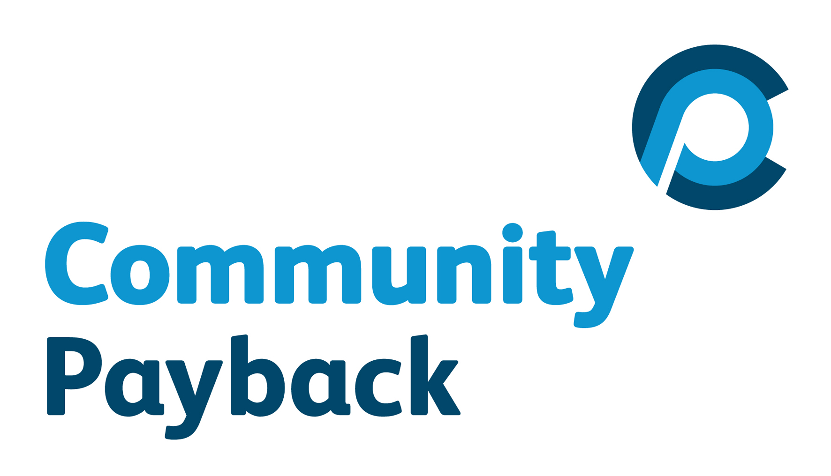

Types of unpaid work projects and activities which have been carried out; the total number of unpaid work hours completed during the year; and information and examples that help to demonstrate how communities benefit from unpaid work.
In Dundee, a total of 72 team projects and 33 individual placements, involving 36,436 hours of unpaid work, were carried out during the reporting period 2014-15. This was an increase of 145 hours completed from the previous year.

Although a marginal increase in hours, this reflects steady improvements in the engagement of people on unpaid work and the associated completion rates. These have risen from 68% in 2010-11, 71% in 2011-12, 73% in 2012-13 and 75% in 2013-14 to 78% in 2014-15.

There has been a focus in Dundee on developing individual placements to offer a more broad range of opportunities to meet the needs of community organisations as well as utilise and develop the skills of people made subject to unpaid work. Consultation with the community also helped to sustain a flow of new referrals involving a variety of different projects.

The list below provides an example of some of the projects and individual placements undertaken:

Projects:
- Broughty Ferry Beach - litter picking main beach and grassy beach. Creation of 3 information boards to sit on the beach.

- Signpost International - extensive internal decorating, plastering and external painting.

- Duntrune Demonstration Garden - painting fences & restoration of 5 benches.

- Craigiebarns Primary School - clearing area to accommodate orchard.

- South Road Bowling Green - creating a ramp to allow access to the green.

- Wellburn House - maintaining market garden, grounds and creating an internal partition wall.

- Gillfillan Church - internal decorating.

- Old Craigie Allotments - repairing and making safe greenhouse.

- Kingsway Care Centre - erecting and painting gazebo, refurbishment of benches, creating concrete plinths and installing benches.

- Under 12’s Project - internal decorating.

- Riverside Footbal Pitches - painting goalposts.

- Whitfield Parish Church - painting external railings.

- West Law Allotments - strimming plots to ground level.

- Richmond Fellowship - erecting fence.

- Aberlour Family Outreach - internal decorating.

- St Johns RC High School - tidying garden & laying slabs.

- Discover Opportunities - delivering Christmas presents

- Flower & Food Festival 2014 - fabricating staging & erecting on site.

- St Marys Community Facility - internal decorating.

- St Aidens Church, Broughty Ferry - painting external railings.

- Kingsway Care Centre - erecting arbour.

- West Law Allotments - clearing plots.

- Middleton Woods - painting metal bridge.

- Craigiebarns Primary School - tidying the Primary 2 garden area during holiday period.

- DEBRA Charity Shop - removal of damaged/broken items to the skip.

- 101 Project - internal decorating.

- Dundee Foodbank - internal decorating.

- Homestart - internal decorating.

- Riverside Nature Reserve - litter picking.

- St Marys Community Church - clearing ground to the side of the church.

- Douglas & Lynch Sports Centres - internal decorating.

- The Giving Garden - laying slabs.

- The Friary - garden.

- Stirling Park Allotments - making secure communal shed.

- Barnhill Rock Garden - edging of paths and fabrication and installation of ramps to bridge.

- Magdalen Yard - painting railings at playpark.

- Eastern Cemetery - restoration of slatted benches.

- Dighty Connect - assisting with the removal of large item from the Dighty Burn & litter picking.

- The Howff - litter picking

Individual Placements:

- Charity Shops – serving customers, steaming, pricing and hanging up clothes. Sorting out other donations.
- Donation Centre – sorting out donations and travelling to other Barnardo shops in Tayside collecting and distributing donations
- Church Cafes – setting up rooms and preparing/serving refreshments.
- Re- Cycle Centres - painting/cleaning furniture and assisting with delivery of furniture
- Food Banks – preparing parcels of food
- Furniture Projects – delivering furniture and assisting with assembling furniture.
- Football Club – gardening, working in club shop
- Animal Charities – cleaning cat pens, grooming and feeding cats
- Mental Health Centre – assisting with activities, admin tasks working in kitchen washing up
- Clothesline Project – washing, drying and ironing clothes for donations
- Theatre – assisting with creative learning workshops
In addition, following requests by Elected Members acting on behalf of local consituents, gardening and garden improvement work was carried out on a routine basis at the home addresses of 13 vulnerable and disabled older adult members of the community at a range of locations across the city.

In general, the focus of all the work was on visible environmental improvement for the community as a whole and for specific groups, such as school pupils, older people and patients. Feedback from people carrying out the work and recipients included;

- People carrying out unpaid work - 93% noted that overall support was positive and 73% believed the time on unpaid work was spent usefully

- Recipients – 100% were satisfied with the timeousness and quality of the work carried out

Quotes from offenders and beneficiaries about the impact of the unpaid work on them and/or the community.
The service asks for feedback from both people carrying out the unpaid work and recipients of projects by way of exit evaluation questionnaires. Comments have included:

Recipients

- They always do a good job, we were very satisfied (decoration work at Day Care Centre for older adults).
- There was a positive attitude and I was happy with the quality of the work (recipient of gardening work).
- It was easy to make contact with the project and they kept me informed of when work would start (Community Bench restoration project).

People carrying out the work

- Learning how to build a roof
- Team building.
- Getting help with forms
- Learning gardening skills
- Completing jobs.
- Flexible times
- Getting on course to sit CSCS Card
- Staying out of trouble
- Team building
- All staff were supportive.
- Made me realise I won’t get in to trouble again.

As part of the feedback, people carrying out the work are also given opportunities to comment on any area where they believe unpaid work could be improved. In this sense, some less favourable comments included:

- Not everybody wants to work together
- Repetitive tasks
- More use of my own skills.
- Need more consideration / flexibility for what’s happening in my personal life.

In response, the service is continuing to extend the range and type of placements to ensure individuals are as appropriately matched as possible. It is also extending the number of individual placements for both men and women.

However, in general, it is clear that both recipients and people carrying out the work viewed projects very positively, with the work appreciated by all recipients and most people undertaking it appreciating opportunities to work, learn and make tangible contributions.

Types of "other activity" carried out as part of the unpaid work or other activity requirement.
In accordance with National Outcomes and Standards for Criminal Justice Social Work, ‘other activities’ can contribute up to 30% of unpaid work hours carried out by people subject to a CPO. This can involve victim awareness, alcohol or drug education, interpersonal skills training, literacy and numracy tutoring, careers advice and confidence training. When combined with the structure offered and the skills acquired when carrying out unpaid work, it can contribute towards reductions in re-offending.

In 2014-15, a minimum of 1124 hours of other activity was carried out. This is almost double the 639 hours carried out in 2013 -14. There has been a focus on seeking out opportunities for other activity and the service has developed links woth a number of other services providing activities. Some of these have been based in a link Hub in the CJSW premises.

A number of individual placements were also designed to help individuals subject to unpaid work develop social skills and prepare them for the job market. This included work at various charity shops and voluntary organisations. Some of them have since continued to work as volunteers.

The service aims to prepare often hard to reach individuals for the job market. The service has a contract with Apex to target this group and provide them with additional supports to help them become job ready.

In 2014-15 we referred 199 individuals to Apex. A total of 61 of these individuals did engage with Apex and 28 of them moved onto a positive destination in education, training and employment. These included 8 progressing to employment, 9 undertaking training courses such as First Aid, I.T. and hospitality, 6 obtaining Construction Certificates, 1 studying horticulture at college and 4 taking on voluntary positions which provide training opportunities. All of these people rated themselves as having made progress due to the support they received in:

- Their ability to use resources available for job searching
- Their ability to complete application forms
- Their ability to prepare a CV and know how and when to use it
- Their ability to disclose convictions to employers
- Their confidence in managing the recruitment process

These results illustrate that although it is difficult for this group to progress into employment during the currency of a CPO, particularly in the current job market, they can, with appropriately targeted support, move towards becoming more job ready. They show that, although unpaid work is largely about providing reparation to the community, both the work itself and ‘other activities’ can make a marked contribution towards helping individuals move forward in their lives.

At the same time, feedback from recipients demonstrates how their work is invariably well received.

The Keep Well initiative is an NHS funded pilot which focuses on the prevention of cardio respiratory illness with at risk groups. Initially, it involved male prison leavers aged 35 years and over but the project has recently extended its remit to include all offenders of the same age. It is co-located with the service and attempts to engage with individuals as they attend unpaid work, offering health checks and advice when they may be more receptive. In 2014-15, a total of 96 individuals engaged with the initiative and the service is presently exploring its sustainability with Tayside NHS.

Activities carried out to consult prescribed persons and organisations, pursuant to section 227ZL of the 1995 Act, and wider communities on the nature of unpaid work and other activities and how the consultation results helped determine which projects were undertaken.
During the year, the service continued to consult with the community on the type of unpaid work projects to be carried out. A key part of this has involved ongoing liaison with and information to the 8 Local Community Planning Partnerships attended by Elected Members, statutory and third sector partners, members of the community and local press. Links with these groups and a dedicated email address for new referrals helped to ensure that new referrals accounted for a significant proportion of all projects carried out and that an even spread of unpaid work projects were carried out across the city.

Where referrals are made, they are first of all considered in terms of whether the work would compete with the local labour market and where relevant, whether the potential recipients would meet or contribute towards any costs of materials. Once confirmed in principle, a health and safety assessment is carried out to ensure any work hazards can be addressed before the work commences in full on an agreed start date. Within this, all referrals are prioritised in accordance with both the nature and size of the request and recipients are kept up to date with anticipated start and completion dates.

Use by the courts of CPO requirements other than unpaid work, for example what, and in what way, different requirements are being used for those whose offending is driven by drug, alcohol and mental health issues; or how requirements such as programme or conduct are being used to address offending behaviour.
In 2014-15, the Sheriff Court imposed a total of 717 new CPOs. When added to the small number of other forms of community sentence for offences which were committed before the introduction of the new legislation in February 2011, a total of 730 new Orders were imposed in this reporting period. This compares with 789 new Orders in 2011-12, 772 in 2012-13 and 671 in 2013-14. The total number of new Orders imposed has therefore remained relatively consistent in the last 4 years but the number of CPOs has increased as the new Order has steadily replaced the old sentences. The CPO and its 9 requirements are now well embedded.

In the last 4 years, the most popular CPO requirement was for unpaid work, with 70% of all Orders containing an unpaid work requirement in each of the years 2011-15. The most popular number of hours imposed also remained the same at between 50 and 100 hours. This was closely followed by supervision requirements, which applied to 404 (56%) of all Orders in 2014-15 and again remained consistent with the first 3 years. However, there has been an increase in the number of Orders with a Court Review provision, from 117 in 2013-14 to 145 in 2014-15. Increasingly, the Court is retaining oversight of the progress of offenders subject to a CPO.

Table 1

Requirement | 2011-12 | 2012-13 | 2013-14 | 2014-15
Programme | 36 | 52 | 97 | 82
Compensation | 11 | 20 | 14 | 18
Residence | 7 | 10 | 5 | 4
Mental health | 9 | 14 | 6 | 11
Drugs | 34 | 25 | 32 | 27
Alcohol | 36 | 28 | 26 | 16
Conduct | 123 | 91 | 29 | 20

In respect of Drugs Treatment Requirements, the number of people subject to requirements has remained relatively stable. When added to offenders subject to the separate Drug Treatment and Testing Order (DTTO), there were 86 in 2011-12, 78 in 2012-13 and 67 in 2013-14 and 47 in 2014-15. However, this does not reflect the number of individuals with a substance misuse problem, with the LSCMI risk assessment tool indicating that this applies to over 80% of offenders. These offenders may be assessed as not able to comply with the more stringent requirements of such an Order, or they may already be in treatment or the substance misuse problem may not be acute enough to warrant such an intensive intervention.

The marked increase in programme requirements, from 36 in 2011-12 to 82 in 2014-15, has been associated with a growing number of people convicted of and sentenced for both internet related sexual offences and domestic violence. This may be a result of increased public reporting and Police detection rates. The service is continuing to monitor these increases and their impact on available resources. People subject to programme requirements for these type of offences are typically expected to engage with the Moving Forward Making Changes (MFMC) programme and a Change Programme.

Any issues affecting access to services which are provided by other partners (e.g. drug and alcohol services) and, where such issues have been identified, what work is underway to resolve them.
All CPOs with substance misuse treatment require a nominated individual to be identified to provide the treatment. Following a re-structure within Tayside NHS and changes to staff roles and responsibilities, there was a short period where a dedicated person could not be named. However, in liaison with the Sheriff Court and NHS colleagues, this issue has now been resolved.

Any other relevant information. This might include details of work which is carried out with offenders on CPOs to address their offending behaviour but which does not fall into the category of a specific requirement.
In respect of the national aim to reduce short-term prison sentences, the proportion of Court Reports resulting in a custodial sentence has maintained a reduction in the last 4 years. At the same time, the proportion of individuals successfully completing a CPO has increased. Tables 2 and 3 below show there have been particular improvements in respect of both 16-17 year olds and adult women. These 2 groups have been prioritised through the Whole Systems Approach and the Community Justice Centre for Women. Progress has also been made in respect of adult males, albeit to a slightly lesser extent. This may reflect the development of a targeted approach towards the use of mentoring. It could improve further as a result of the new Intensive Support Programme implemented in 2014-15.

Table 2 – proportion of Court Reports resulting in a custodial sentence 2011-15

Year | 16-17 years | Females | Males | Total
2011-12 | 18% | 15% | 27% | 24%
2012-13 | 12% | 11% | 19% | 17%
2013-14 | 5% | 10% | 22% | 19%
2014-15 | 8% | 9% | 20% | 18%

Table 3 – proportion of offenders successfully completing CPOs 2011-15

Year | 16-17 years | Females | Males | Total
2011-12 | 34% | 40% | 59% | 52%
2012-13 | 55% | 72% | 63% | 64%
2013-14 | 70% | 76% | 71% | 72%
2014-15 | 69% | 78% | 76% | 76%

COMPLETED BY: Glyn Lloyd, Service Manager, Criminal Justice Service

DATE: 30 October 2015

CONTACT FOR QUERIES ABOUT THE REPORT

Name: Glyn Lloyd

E-mail:

Telephone: 01382 435017

Appendix 2 – Angus Community Payback Order Annual Report

COMMUNITY

PAYBACK ORDER

ANNUAL REPORT

FINANCIAL YEAR: 2014/15

LOCAL AUTHORITY: Angus Council

Types of unpaid work projects and activities which have been carried out; the total number of unpaid work hours completed during the year; and information and examples that help to demonstrate how communities benefit from unpaid work.
In 2014/15 there has been a 9.6% decrease in the number of CPO’s issued compared to the previous year; the use of predecessor orders remained low accounting for 2.8 % of total orders.
Angus had 347 CPOs made on 296 service users compared to 384 on 238 the previous year so that while this represents a decrease in the total number of orders there has also been an increase of 58 (20%) in the number of individuals subject to a CPO.
Of the 347 CPOs:
- 152 orders we made with (44%) – a total of 2287 months were given at an average 15 months per CPO with a supervision requirement. This is an increase of 6 orders and 19 months.
- 279 orders were made with UPW – a total of 30207 hours were imposed at an average of 108hrs per CPO with an UPW requirement. This is a decease of 25 orders but an increase of 2922hrs / 18.25hrs average increase per order.

The 347 CPOs can be broken down as follows:
- 68 with supervision only (19.59%)
- 40 with supervision AND L1 UPW (11.52%)
- 44 with supervision AND L2 UPW (12.68%)
- 128 with L1 UPW only (36.88%)
- 67 with L2 UPW only (19.30%)

Thus 279 (80%) of all CPOs included UPW, of which 168 (60%) of all CPOs had L1 and 111 (40%) had L2.
84 (24%) were “combination” orders – consisting of both supervision AND UPW (some also include other additional requirements)

Types of Unpaid Work Undertaken
- Community Garden
- Response to vandalism including graffiti removal, repairs and addressing fire hazards
- Forfar town improvements – improving dereleict area, including landscaping and development of communal gardens
- Gardening Schemes - individual homes
- Furniture collections and deliveries on behalf of the Forfar Resource Store
- Supporting charity shops move stock, collect and deliver large items
- Individual house moves for homeless and vulnerable people
- Blythswood Charity collections
- Footpath maintainence, Sidlaw Path network
- Environmental project at Monikie Country Park
- Litter picks when required
- Snow clearing and gritting – including residential homes for the elderly
- Individual placements with local charity groups
- Removing fly tipping.

Quotes from people on CPO’s and beneficiaries about the impact of the unpaid work on them and/or the community.
Quotes from people on CPO’s

The following is a poem composed by members of the Glen Isla Project (women offender’s) Unpaid Work Team

We are the Glen Isla project community service team
Righting our wrongs by keeping the streets clean
Chopping down trees at ole Crombie park
Painting the signpost at the cliffs, we are certainly making our mark

Heather is our boss she is loud but doesn’t shout
Hounds us with camera tho what the feck is that about
You can talk to her about anything tho, she will always have your back
It’s funny when she turns the air blue, she certainly loves a good craic

Stevie is the supervisor, he likes to chit and chat
Always busy running around, doing this or doing that
He likes to tell us random facts, we don’t know if they’re fictional or true,
You are the captain of our bus Stevie and we salute you

As for the rest of us, no two are the same
A lively bunch of characters, but our names we shall refrain
All working together, we have certainly learnt a lot,
New skills have been developed while our transgressions are forgot

Glen Isla project service is to focus on rehabilitation
Helping women offenders to make a positive transformation
Providing support, advice or a blunt chat if required
The support workers here are certainly to be admired.

Other quotes from people on CPO’s

- "Good timing and taken Home after work sessions - new attitude and learnt new info"

- "Would like to say thank you to everybody that helped me through a difficult time never judged me and always professional"

- "Thanks to the Supervisors for supporting us" // "Enjoyed it and the crack with the group throughout"

- "Felt I had support and the help that I needed"

- "It was well run, the staff was helpful and approachable and, being a Social Science student, I was able to pick up some practical skills (like gardening!)"

- "Cutting grass for eldery people. I felt good doing it for them, as they can't do it."

- "All staff were amazing and my supervisor was a joy to work with / defo bonus for him xxxx from Arbroath"

- "Meeting new people and doing good charity work that I really enjoyed doing"

Comments from beneficiaries

- “absolutely delighted with the work”

- “everything was left in such a good condition when you left”

- “thanks to be passed on to you and the team for all your hard work”

Types of "other activity" carried out as part of the unpaid work or other activity requirement.
During 2014/15, we have continued to develop our range of services provided under “other activity” and to match these services more closely to the initial assessment of the individual service user’s needs and offending behaviours. This has often been through partnership arrangements with other local authority services and third party providers.

The Angus Drug and Alcohol Learning Partnership is a joint arrangement between CJS, SW Drug and Alcohol Team, Tayside Substance Misuse Service, and the Arrest Referral Scheme (Action for Children). It provides a referral screening and sign posting service as well as providing training and learning development for staff delivering services to the overlapping CJS/drug and alcohol client group. The screening group has been influential in ensuring that offenders with substance issues are properly routed to the best type of service for them; a number of these are delivered under “other activity” to service users on CPO.

Much of the desitance work carried out under “other activity” is undertaken by our criminal justice assistants, overseen by the supervising case manager (social worker). Input is delivered on a one-to-one basis and through a range of groupwork provision. At different times this year, groupwork has included the general offending group, positive relationship group, moving on group and employability group. Groupwork projects vary in their thematic emphasis but will cover a range of desistance factors, such as employment, finances, relationships, housing, education, self care, heath etc.

We have strong links with local third party providers (APEX, Community Learning and Development and Eclipse) in the field of employment and reviewed our employment pathway so that literacy screening is available much more promptly to all service users on “other activity”.

Angus is part of the Tayside PSP for mentoring, delivered by the Tayside Council on Alcohol (TCA). The development of mentoring in Angus has been important in supporting the attendance of service users at programmes of planned work.

The continuing development of our women’s service, the Glen Isla Project has resulted in the initiation of specific women’s groups for self care including budgeting, food preparation etc and therapeutic groups.

Our focus in the coming year will be:

- To further develop the range of “other activity” we can provide (e.g. a Glen Isla DIY group)
- Continue literacy screening for all service users with routes into employment or training
- Improve general health through greater participation in physical activity and sport

Activities carried out to consult prescribed persons and organisations, pursuant to section 227ZL of the 1995 Act, and wider communities on the nature of unpaid work and other activities and how the consultation results helped determine which projects were undertaken.
We are currently conducting a survey via the Angus citizen’s panel as a means of community consultation. Amongst other questions the panel will be asked to consider what work the Unpaid Work service could usefully complete.

Recently we have completed work to review the role of the Unpaid Work Officer in Angus. The role has been refocused on establishing wider community links with a view to identifying team projects and single placements.

We are currently planning a service whereby new tenacies to be occupied by care leavers will be decorated by Unpaid Work staff. This will be a joint project with the TCAC team and Angus Council Housing service.

Our community garden has continued to develop in Arbroath and to be supported by the project group, which includes neighbours’ representatives and members of local schools, colleges and other community groups. These include the ‘Forfar in Bloom’ project where a number of works have been undertaken across the town to improve the aesthetic.

We continue to engage with elected members and they regularly make referrals for UPW, highlighting community needs. They are keen to provide feedback and to ensure responsiveness to locally identified need.

We continue to receive referrals from members of the public and response time to these has improved to the extent that there is rarely a waiting list. It is our intention to formalise feedback from these pieces of work as at present we do not routinely gather feedback and the comments quoted earlier are entirely unsolicited. This would help us to make any required adjustments to our service.

As we move into a transition period from the CJA to Community Planning Partnerships we will be looking establish consulation measures as a intergral part of the new arrangements.

Use by the courts of CPO requirements other than unpaid work, for example what, and in what way, different requirements are being used for those whose offending is driven by drug, alcohol and mental health issues; or how requirements such as programme or conduct are being used to address offending behaviour.
Of the 347 CPO’s disposed in the time period concerned:
152 (44%) had a supervision requirement
19 (5%) had a compensation requirement
57 (16%) had a programme requirement
3 (1%) had a residence requirement
4 (1%) had a mental health treatment requirement
3 (1%) had a drug treatment requirement
14 (4%) had an alcohol treatment requirement
12 (3%) had conduct requirements

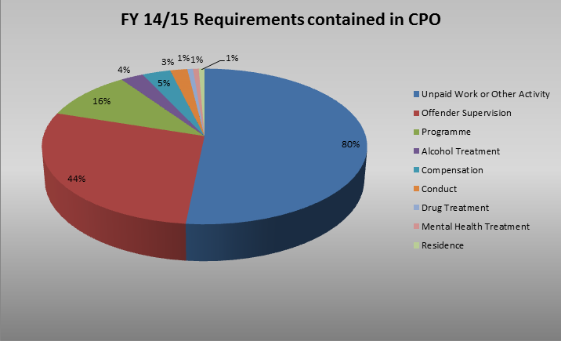

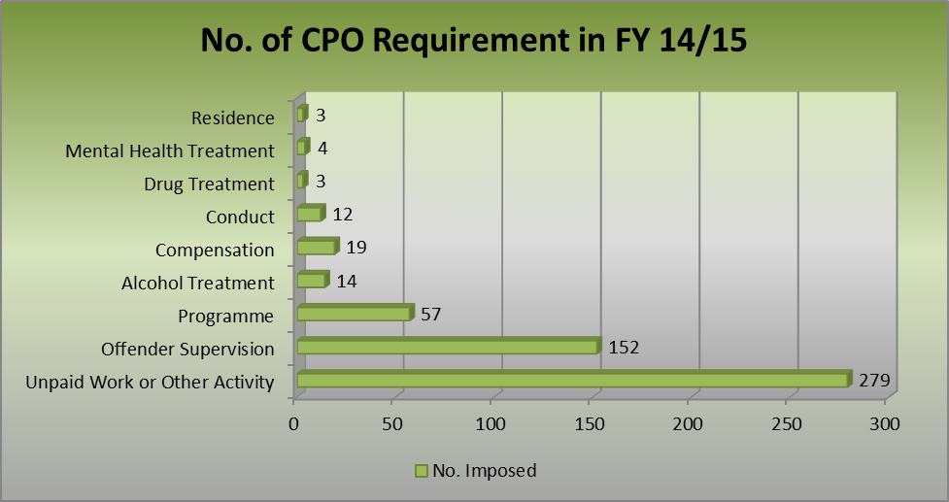

Structured Deferred Sentences
These continue to be popular for sentencers in Angus with 151 disposals on 63 individuals an increase of 42% High Tariff Structured Deferred Sentences being used in 14/15. The demand for Low Tariff SDS has increased to 36 (a increase of 22%). This makes a significant demand on resources given the intensive nature of High Tariff SDS however their usage has been effective particularly in regard to women offenders as can be evidenced by the exceptionally low breach rates.

Women account for 40% of the total individuals, 51% of the SDS disposals and 6% of the breaches; Men account for 60% of the individuals, 49% of the SDS disposals and 15% of the breaches.
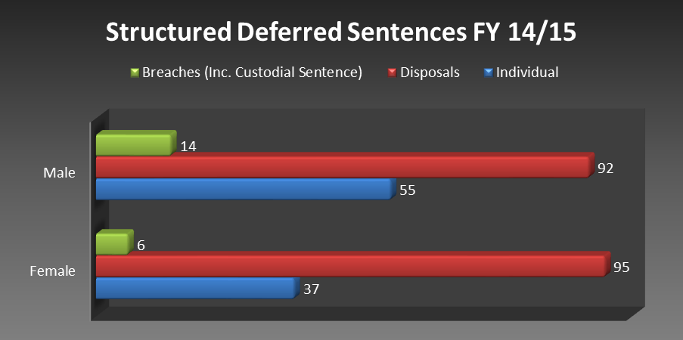

Any issues affecting access to services which are provided by other partners (e.g. drug and alcohol services) and, where such issues have been identified, what work is underway to resolve them.
As a relatively small Local Authority area we are fortunate that close relationships with other services exist and it is easy to resolve any issues as they emerge. CJS continues to meet regularly with other partners and officers within the service sit on various strategy groups e.g. Angus Violence Against Women Partnership, the Angus Alcohol and Drugs Partnership Strategy group etc which means that we are aware of any issues at an early stage and can address them accordingly. Many of our partners will move into the Health and Social Care Partnership and this will overlap with a transition period for CJS consequently we will require to manage these relationships carefully.

Any other relevant information. This might include details of work which is carried out with people on CPOs to address their offending behaviour but which does not fall into the category of a specific requirement.
The development of our multi agency Women Offender’s team, which includes a nurse, has meant that we have been able to address the health inequalities without requiring a specific requirement. Research indicates trauma is likely to be prevalent for many women in the justice system and having a nurse in our service has meant that physical and mental health needs have been addressed more directly .

Outcome (In order of most common area in which women made progress | Got Better | Stayed the same | Got worse
Physical health | 80% | 13% | 7%
Housing | 50% | 40% | 10%
Substance misuse | 50% | 46% | 4%
Mental health | 43% | 57% | 0%
Finances | 41% | 59% | 0%
Family/ social relationships | 37% | 56% | 7%
Attitude to desistance | 36% | 64% | 0%
Sexual health | 36% | 64% | 0%
Views on offending | 36% | 64% | 0%
Engagement with services | 33% | 50% | 17%
Leisure activities | 28% | 72% | 0%
Problem solving skills | 27% | 67% | 7%
Work, volunteering and training | 21% | 76% | 3%
Willingness to work on problems | 20% | 73% | 7%

Offences that may previously have been addressed by means of a fine or Unpaid Work Order are now dealt with by an initial period of a Structured Deferred Sentence;(see figure above) this enables a more throrough assessment and testing of compliance. It also ensures that where previously women may have been more likely to breach orders because their needs were not being addressed this is now less likely to be the case. We are fortunate that local sheriffs see the value of this process and set Court reviews on a regular basis so that they can see for themselves what progress the women are making.

COMPLETED BY: Alan Hope

DATE: 09/11/15

CONTACT FOR QUERIES ABOUT THE REPORT

Name: Alan Hope

E-mail: HopeA@angus.gcsx.gov.uk

Telephone: 01241 438383

Appendix 3 – Perth and Kinross Community Payback Order Annual Report

COMMUNITY

PAYBACK ORDER

ANNUAL REPORT

FINANCIAL YEAR:2014/2015

LOCAL AUTHORITY:PERTH & KINROSS

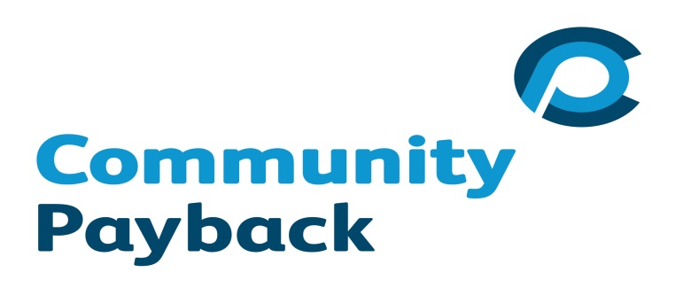

Types of unpaid work projects and activities which have been carried out; the total number of unpaid work hours completed during the year; and information and examples that help to demonstrate how communities benefit from unpaid work.
The team has had a very productive year and staff have ensured that the clients are occupied with worthwhile tasks that have most impact and benefit to the community.

There were 312 Unpaid Work Requirements successfully completed in 2014/15. The total number of unpaid work hours completed 28,542.

The following graph shows the increasing number of unpaid work requirements and the average length of unpaid work requirements being imposed by the Courts.

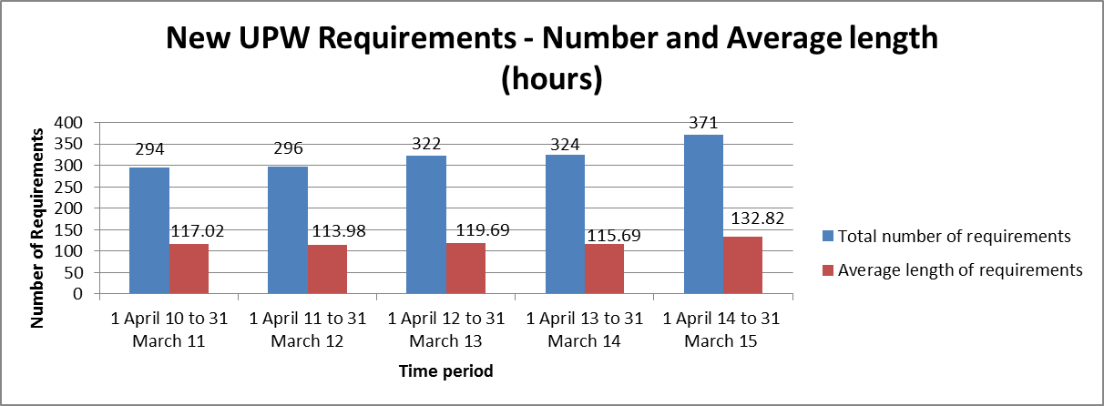

A number of larger projects have been initiated including:

- Preparatory activity for the Ryder Cup
- Chewing gum removal from streets in Perth City Centre
- Perth in Bloom (horticulture)

The management and delivery of the above activities have been balanced with completing a higher volume of smaller tasks to improve communities including:

- War memorial repair
- Graffiti removal
- Garden clearance
- Outdoor furniture renovation
- Decorating
- Litter picking

Every effort is made to generate publicity around these jobs to increase visibility of ‘Payback’ to the community.

The Unpaid Work Team is accommodated at Westbank House in Perth which is an extensive site and also houses Westbank Enterprises. This is a social enterprise which runs the Council plant nurseries in partnership with the Shaw Trust and Perth and Kinross Council Community Greenspace. The Unpaid Work Team use a partially converted Roads Department Shed as a Workshop in which they store their outdoor tools and build and repair furniture and other wooden projects. This co-location provides many opportunities for partnership working and promoting employability skills and opportunities for offenders. The contribution of the Unpaid Work Team in supporting the villages in the Perth and Kinross in Bloom displays is critical.

The principle of Community Payback works well and has the potential to add further value to other initiatives in the future e.g. providing support to deal with problems discovered during Joint Home Safety Visits, tackling existing graffiti, working with Eco- Schools projects, community engagement through the crazy golf holes constructed by the team for the Ryder Cup.

Examples of specific projects that have carried out by the Unpaid Work team in 2014-15 include the following:

Partnership with PLUS PERTH – This charity benefits adults with learning difficulties in Perth. They obtained a plot of land behind buildings in South Street, Perth and purchased a large greenhouse to be used on it. They approached the Unpaid Work Team and as a result the team cleared the site of undergrowth etc. The team then built raised beds from timber held at Westbank and assembled the greenhouse. The plot was laid out to be wheelchair friendly to encourage users to access the area and plant vegetables etc. The Unpaid Work Team remains in regular communication with this charity and they have another request in the pipeline for additional similar work to be done.

Meigle Primary School – A programme of work has been undertaken to improve the environment for the children and the appearance of the village which includes repainting the school hall and the playground railings.

Vale of Atholl Football Pavilion – The local Pitlochry Amateur Football Team pavilion had fallen into disrepair and was suffering from damp. The Unpaid Work Team dug out an area to the rear and installed drainage to alleviate the damp and repainted the inside and outside. Following the work carried out at that location, Blairgowrie F.C. approached the Unpaid Work Team and they were subsequently involved in carrying out paintwork on their external property and fencing. As further organisations become aware of the Unpaid Work Team it will likely see an increase in demand for our services.

Ryder Cup – During the previous year the team created a wooden crazy golf course as part of the Ryder Cup celebrations. Over the summer this has been offered to various fetes and fairs and deployed to help local organisations to raise money. During the Ryder Cup the Unpaid Work Team were involved in a number of projects. One was the development of the central area of the new roundabout at the ends of the new road from the Gleneagles Railway Station. This area was developed by the team to accurately represent a golf course hole in miniature along with an area of rough planting to represent the rough of a golf course. This was finished off with the erection of large vertically installed golf clubs set into the ground and that has become a permanent feature with a plaque recognising the work done by the Team inserted into the stone wall forming part of the feature.

St Martins Church, Crieff – This disused church was being used for drinking and drug taking and had become an eyesore. The team worked with the Safer Community Investigators and the Police to clear the grounds and secure and board up the building.

Craigie Tennis Club – A programme of fence building and slabbing around the Craigie pavilion was undertaken by the Team. The success of this programme led to a request from Luncarty Tennis Club to remove their pavilion and fence the area once the new changing facilities were installed.

Westbank Enterprise – The Unpaid Work Team is co-located with Westbank Enterprises which runs the former council nurseries. This year the partnership between the two has strengthened further still with placements being offered to clients in the nurseries and a continued commitment to Beautiful Perth and the ‘In Bloom’ organisations. Through this the team empty and fill hanging baskets, deliver plants to outlying areas, paint poles and hangers and plant out and maintain an extensive area adjacent to Perth Leisure Pool.

Environmental Activity – The Team has been involved in a large number of litter picks, path clearances and chewing gum removal which enhances the appearance of the towns and villages of Perth and Kinross. They have repaired and painted wooden furniture, monuments and sculptures. It has been a key player in the Graffiti Strategy which is making a significant impact on the appearance of the City Centre in particular. This involves an innovative partnership with Right Track – a structured deferred sentence programme for 16-25 year olds – whereby the offenders volunteer for unpaid work one morning a week. This approach not only benefits the community but also the young people involved and is useful to the Sheriffs by affording them additional information about the young person when making their sentencing decisions which may include subsequent unpaid work.

Quotes from offenders and beneficiaries about the impact of the unpaid work on them and/or the community.
The following are examples of quotes received during the current year:

Comment taken from the Perth Plus Mental Health Group:

“We were all so pleased this week when the guys from the community payback team came down to build us our long planned raised beds. We take this opportunity to say thank you to the community payback team for their hard work.”

Letter from Crieff Community Council following work carried out at the Old St Michael’s Parish Church Hall, Crieff

“We would like to thank you very much indeed for all the help you provided in securing these premises. We are really grateful, and would ask that you pass on our thanks to the rest of the team.”

Letter received from the Chairperson of Muthill In Bloom thanking the team for work carried out

“On behalf of Muthill in Bloom can I take this opportunity to say thank you for all the work your team has recently carried out on our behalf. Being a very small committee we try our hardest to brighten up the village but extra help is always very much appreciated”.

Excerpt from a letter received from the Chairman of the Blairgowrie and Rattray Community Club for painting work carried out on a Pavilion in Davie Park Rattray.

“I would like to confirm that the painting of the pavilion at the Davie Park has been completed. It is looking superb, never been as good for many a year. A big thank you to Charlie (Charlie Richards Project Officer) and the Payback Team, a good job well done.”

Offender comments (taken from CPO completion feedback questionnaires)

“Carrying out tasks I wouldn’t normally do. Learning new skills.”
“Having a routine to adhere to whilst unemployed”
“Varied jobs and the ability to do things worthwhile in the community”
“Gave me something to do and has motivated me to do other things”
“Learning different skills and meeting the people who taught me these skills”
“The project officers were all very helpful and all willing to help you learn new skills”
“Getting a routine of working again”
“I enjoyed being part of a team and doing things for the community”

Types of "other activity" carried out as part of the unpaid work or other activity requirement.
A variety of other activities have been undertaken as part of the “other activity” component of unpaid work requirements. These have included the following:

Childcare/parenting for female offenders - Through the One-stop Women’s Learning Service (OWLS) for female clients, women who have the diagnosis of Personality Disorder and are also mothers with young babies are placed on training courses to develop their skills in respect of childcare/parenting. Whilst this directly benefits them and their children, it is hoped that they will maintain the skills they have learned to improve their coping strategies and becoming positive role models for their children.

Employability - The Public Protection Team have worked with the Unpaid Work Team to develop an employability group work programme whereby offenders are referred to a 5 week course to develop employment skills and an improved attitude to employment. This is being delivered onsite at the Unpaid Work complex which is adjacent to the Shaw Trust. Following completion of the Employability course representatives from Shaw Trust are invited to discuss their project with clients. This has proven a successful introduction with a number of our clients going on to apply and accept positions within the Shaw Trust Enterprise.

Activities carried out to consult prescribed persons and organisations, pursuant to section 227ZL of the 1995 Act, and wider communities on the nature of unpaid work and other activities and how the consultation results helped determine which projects were undertaken.
The Unpaid Work Team supervisor contacted and visited Community Councils within the area to promote the service and establish the needs of the community.

A Communication Strategy has been developed by the service and provides a structure for marketing the capability and capacity of the Unpaid Work Team. A weekly update is provided to the Council’s Communications Team and ‘word of mouth’ recommendation is encouraged by management through elected members, Community Councillors, sports associations, in the local press and through satisfied customers.

The Unpaid Work Team is completely integrated into the Community Planning Partnership process and is regarded as a valuable resource. The Team and wider Partnership consults widely with residents and other stakeholders through tactics such as: Customer Satisfaction Survey, Street a Week (where Community Wardens pick an area and visit households to establish any problems that they are experiencing), liaison with elected members and liaison with Community Councils. These engagement activities help to inform the work of the partnership at an operational level and has enabled the Unpaid Work Team to get involved with multi agency operational activity such as:

- Undergrowth removal as part of a campaign to reduce the level of drug litter
- Litter picking to resolve wild camping issues
- Burn clearing
- Installation of Water Safety equipment at a high risk spot on the Tay at Perth.
- Graffiti removal

The Unpaid Work Team is integrated with the rest of the Safer Communities Team –Investigators, Wardens, Project Officers and Police. The services the team can provide are marketed by each member of the team and 2014/15 has seen a significant rise in demand for their services. The most effective form of marketing is word of mouth and staff tend to see trends in applications where this has been case: schools, football clubs, tennis clubs, and different organisations in the same village.

Management are called upon to speak at a variety of organisations about the work of the Unpaid Work Team: community councils, residents’ organisations and other agencies.

The increased demand is evidenced by the recent need to streamline and modernise the application process. This increase has been essential to meet the challenge of the increasing numbers and length of Unpaid Work Orders.

The new business process highlights the need to market the successes and efforts of the Unpaid Work Team and has led management to broaden the definition of Unpaid Work from not only those on Community Payback but also to use the Right Track Team and HMP Perth to deliver ‘unpaid’ community projects.

Use by the courts of CPO requirements other than unpaid work, for example what, and in what way, different requirements are being used for those whose offending is driven by drug, alcohol and mental health issues; or how requirements such as programme or conduct are being used to address offending behaviour.
The Positive Relationship Programme has been running from 2013. This has been a direct response to the growing number of general CPO clients disclosing or evidencing difficulties/issues in managing personal/family relationships. This is not directly offence focused. However in those cases where there is an explicit need in relation to domestic abuse/violence, this in-depth work is currently carried out on a 1:1 basis with Social Workers.
The Drink Driving Group was re-established in 2013 due to an increasing number of CPOs for drink driving offences which allowed the running of a group work programme to be viable. A women only group has been successfully delivered in 2014 with the programme being redesigned and shortened to enable a more time efficient and gender specific programme to be delivered.
Moving Forward, Making Changes was implemented in 2014 and replaced the Community Sex Offender Groupwork Programme. This is being successfully delivered as a Programme Requirement in conjunction with Tay Project (Dundee Criminal Justice Social Work). Client suitability for this programme is determined at the court reporting stage and is very much needs-led tied to their Stable & Acute 07 risk assessment and LSCMI.

Any issues affecting access to services which are provided by other partners (e.g. drug and alcohol services) and, where such issues have been identified, what work is underway to resolve them?
Joint working with Tayside Substance Misuse Service (TSMS) was implemented in 2014 with a dedicated TSMS Nurse located with criminal justice social workers and also attached to the OWLS. However, during 2014-15, Drug and Alcohol Requirements ceased to be delivered jointly with TSMS. Unfortunately, due to staffing issues, TSMS were unable to maintain a specific worker allocated to CPO cases. This has resulted in a number of clients who should have been breached for non-compliance not being returned to Court as information was not as readily available from TSMS in relation to compliance.
In order to try and resolve this situation, a member of the Public Protection team has been attending weekly TSMS team meetings to share information regarding client progress. However, TSMS feel unable to share information due to data protection concerns. Discussions are taking place between Managers and Data Compliance Officers in order to ensure that an appropriate resolution can be found.

Any other relevant information. This might include details of work which is carried out with offenders on CPOs to address their offending behaviour but which does not fall into the category of a specific requirement.
OWLS: The One-stop Women’s Learning Service has been operating since
February 2013 in response to a recommendation within the report from the
Commission on Women Offenders chaired by Dame Elish Angiolini. OWLS initially operated every Thursday and specific rooms at Drumhar Health Centre were utilised both for appointments and as a drop-in facility. All work is now carried out at a new centre based in West Mill Street, Perth; a dedicated space for women only. 100 women have participated in OWLS since its inception. There are currently 54 women attending OWLS with ages ranging from 19 to 69 years. The women have committed offences including misuse of drugs, dishonesty, assault and offences against children, i.e. neglect and physical abuse. The work at OWLS involves both individual appointments with services and group work. All the women who have been eligible to attend OWLS have chosen to do so. Discussions are ongoing to enable the new centre in West Mill Street, Perth to be open 6 days a week and some evenings. It is hoped that in the future the centre would become a “Women’s Centre”, allowing access to not just OWLS clients but also to women who would benefit from the services available there. The financial sustainability of the centre is also being discussed with the voluntary sector and various avenues are currently being explored.

Counselling: The Public Protection Team has a qualified Counsellor who has been working with clients for the past three years. This has enabled clients to be fast-tracked into receiving this type of support and in addressing client’s complex emotional needs and difficulties. This service runs at capacity of eight clients per week offering up to eight sessions or as required. Feedback from clients has been extremely positive with clients reporting they feel more in control of their lives and have a greater understanding of their behaviours, reactions and consequences. During 2014-15, this service has become essential in some cases where clients are denied access to mental health services due to being diagnosed with a personality disorder and therefore not meeting NHS criteria for treatment.

COMPLETED BY: Nicola Rogerson

DATE: 13 October 2015

CONTACT FOR QUERIES ABOUT THE REPORT

Name: Nicola Rogerson

E-mail: NRogerson@pkc.gcsx.gov.uk

Telephone: 01738 444244

